Lab 10
BT1
package bt1;

import io.restassured.RestAssured;
import io.restassured.builder.RequestSpecBuilder;
import io.restassured.filter.log.RequestLoggingFilter;
import io.restassured.filter.log.ResponseLoggingFilter;
import io.restassured.http.ContentType;
import io.restassured.specification.RequestSpecification;
import org.testng.annotations.BeforeClass;
import org.testng.SkipException;

public class ApiBaseTest {

protected RequestSpecification requestSpec;
protected String apiKey;

@BeforeClass
public void setupApiSpec() {
apiKey = resolveApiKey();
if (apiKey == null || apiKey.isBlank()) {
throw new SkipException("Missing ReqRes API key. Set REQRES_API_KEY or -Dreqres.api.key=<your_key>.");
}

requestSpec = new RequestSpecBuilder()
.setBaseUri("https://reqres.in")
.setBasePath("/api")
.setContentType(ContentType.JSON)
.addHeader("reqres_b39fc6f91e47413d846fda0487449582", apiKey)
.addFilter(new RequestLoggingFilter())
.addFilter(new ResponseLoggingFilter())
.build();

RestAssured.enableLoggingOfRequestAndResponseIfValidationFails();
}

private String resolveApiKey() {
String keyFromProperty = System.getProperty("reqres.api.key");
if (keyFromProperty != null && !keyFromProperty.isBlank()) {
return keyFromProperty;
}
return System.getenv("REQRES_API_KEY");
}
}

package bt1;

import org.hamcrest.Matchers;
import org.testng.annotations.Test;

import static io.restassured.RestAssured.given;
import static org.hamcrest.Matchers.emptyOrNullString;
import static org.hamcrest.Matchers.anEmptyMap;
import static org.hamcrest.Matchers.equalTo;
import static org.hamcrest.Matchers.greaterThan;
import static org.hamcrest.Matchers.matchesPattern;

public class UserGetApiTest extends ApiBaseTest {

@Test(description = "BT1 - Test 1: GET /api/users?page=1")
public void testGetUsersPage1() {
given()
.spec(requestSpec)
.queryParam("page", 1)
.when()
.get("/users")
.then()
.statusCode(200)
.body("page", equalTo(1))
.body("total_pages", greaterThan(0))
.body("data.size()", greaterThan(0));
}

@Test(description = "BT1 - Test 2: GET /api/users?page=2")
public void testGetUsersPage2RequiredFields() {
given()
.spec(requestSpec)
.queryParam("page", 2)
.when()
.get("/users")
.then()
.statusCode(200)
.body("page", equalTo(2))
.body("data.id", Matchers.everyItem(Matchers.notNullValue()))
.body("data.email", Matchers.everyItem(Matchers.notNullValue()))
.body("data.first_name", Matchers.everyItem(Matchers.notNullValue()))
.body("data.last_name", Matchers.everyItem(Matchers.notNullValue()))
.body("data.avatar", Matchers.everyItem(Matchers.notNullValue()));
}

@Test(description = "BT1 - Test 3: GET /api/users/3")
public void testGetUserById3() {
given()
.spec(requestSpec)
.when()
.get("/users/3")
.then()
.statusCode(200)
.body("data.id", equalTo(3))
.body("data.email", matchesPattern("^[A-Za-z0-9._%+-]+@reqres\\.in$"))
.body("data.first_name", Matchers.not(emptyOrNullString()));
}

@Test(description = "BT1 - Test 4: GET /api/users/9999")
public void testGetUserNotFound() {
given()
.spec(requestSpec)
.when()
.get("/users/9999")
.then()
.statusCode(404)
.body("$", anEmptyMap());
}
}

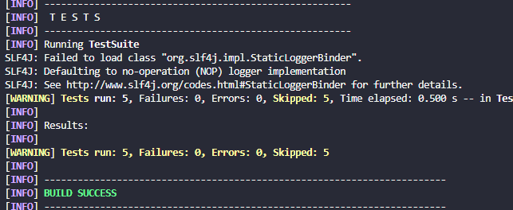

BT2
package bt2.model;

import com.fasterxml.jackson.annotation.JsonInclude;
import com.fasterxml.jackson.annotation.JsonProperty;

@JsonInclude(JsonInclude.Include.NON_NULL)
public class CreateUserRequest {

@JsonProperty("name")
private String name;

@JsonProperty("job")
private String job;

public CreateUserRequest() {
}

public CreateUserRequest(String name, String job) {
this.name = name;
this.job = job;
}

public String getName() {
return name;
}

public void setName(String name) {
this.name = name;
}

public String getJob() {
return job;
}

public void setJob(String job) {
this.job = job;
}
}

package bt2.model;

import com.fasterxml.jackson.annotation.JsonIgnoreProperties;
import com.fasterxml.jackson.annotation.JsonProperty;

@JsonIgnoreProperties(ignoreUnknown = true)
public class UserResponse {

@JsonProperty("name")
private String name;

@JsonProperty("job")
private String job;

@JsonProperty("id")
private String id;

@JsonProperty("createdAt")
private String createdAt;

@JsonProperty("updatedAt")
private String updatedAt;

public String getName() {
return name;
}

public void setName(String name) {
this.name = name;
}

public String getJob() {
return job;
}

public void setJob(String job) {
this.job = job;
}

public String getId() {
return id;
}

public void setId(String id) {
this.id = id;
}

public String getCreatedAt() {
return createdAt;
}

public void setCreatedAt(String createdAt) {
this.createdAt = createdAt;
}

public String getUpdatedAt() {
return updatedAt;
}

public void setUpdatedAt(String updatedAt) {
this.updatedAt = updatedAt;
}
}

package bt2;

import bt2.model.CreateUserRequest;
import bt2.model.UserResponse;
import io.restassured.response.Response;
import org.testng.Assert;
import org.testng.annotations.Test;

import java.time.Instant;
import java.util.HashMap;
import java.util.Map;
import java.util.UUID;

import static io.restassured.RestAssured.given;
import static org.hamcrest.Matchers.blankOrNullString;
import static org.hamcrest.Matchers.equalTo;
import static org.hamcrest.Matchers.not;
import static org.hamcrest.Matchers.notNullValue;

public class CrudUserApiTest extends ApiBaseTest {

@Test(description = "BT2.1 - POST /api/users tao user")
public void testCreateUser() {
CreateUserRequest request = new CreateUserRequest("BT2_User_" + UUID.randomUUID(), "QA Engineer");

given()
.spec(requestSpec)
.body(request)
.when()
.post("/users")
.then()
.statusCode(201)
.body("name", equalTo(request.getName()))
.body("job", equalTo(request.getJob()))
.body("id", not(blankOrNullString()))
.body("createdAt", not(blankOrNullString()));
}

@Test(description = "BT2.2 - PUT /api/users/{id} cap nhat user")
public void testUpdateUserByPut() {
UserResponse created = createUser("PUT_Initial", "Junior QA");
String userId = created.getId();

CreateUserRequest updateRequest = new CreateUserRequest("PUT_Updated", "Senior QA");

UserResponse updated =
given()
.spec(requestSpec)
.body(updateRequest)
.when()
.put("/users/{id}", userId)
.then()
.statusCode(200)
.body("job", equalTo(updateRequest.getJob()))
.body("updatedAt", notNullValue())
.extract()
.as(UserResponse.class);

Assert.assertNotNull(updated.getUpdatedAt(), "updatedAt must not be null");
Assert.assertNotEquals(updated.getUpdatedAt(), created.getCreatedAt(), "updatedAt should differ from createdAt");
}

@Test(description = "BT2.3 - PATCH /api/users/{id} cap nhat mot phan")
public void testPatchUserPartialUpdate() {
UserResponse created = createUser("PATCH_Initial", "Manual QA");

Map<String, Object> patchBody = new HashMap<>();
patchBody.put("job", "Automation QA");

String oldTimestamp = created.getCreatedAt();

String updatedAt =
given()
.spec(requestSpec)
.body(patchBody)
.when()
.patch("/users/{id}", created.getId())
.then()
.statusCode(200)
.body("job", equalTo("Automation QA"))
.body("updatedAt", not(blankOrNullString()))
.extract()
.path("updatedAt");

Assert.assertTrue(Instant.parse(updatedAt).isAfter(Instant.parse(oldTimestamp)), "updatedAt must be newer than createdAt");
}

@Test(description = "BT2.4 - DELETE /api/users/{id} xoa user")
public void testDeleteUser() {
UserResponse created = createUser("DELETE_Initial", "QA");

Response deleteResponse =
given()
.spec(requestSpec)
.when()
.delete("/users/{id}", created.getId())
.then()
.statusCode(204)
.extract()
.response();

Assert.assertTrue(deleteResponse.asString().isBlank(), "DELETE response body must be empty");
}

@Test(description = "BT2.5 - POST -> GET xac nhan")
public void testPostThenGetVerify() {
String existingFirstName =
given()
.spec(requestSpec)
.when()
.get("/users/2")
.then()
.statusCode(200)
.extract()
.path("data.first_name");

CreateUserRequest request = new CreateUserRequest(existingFirstName, "API Tester");

UserResponse created =
given()
.spec(requestSpec)
.body(request)
.when()
.post("/users")
.then()
.statusCode(201)
.body("id", not(blankOrNullString()))
.extract()
.as(UserResponse.class);

given()
.spec(requestSpec)
.when()
.get("/users/2")
.then()
.statusCode(200)
.body("data.first_name", equalTo(request.getName()));

Assert.assertNotNull(created.getId(), "Created user id must not be null");
}

private UserResponse createUser(String namePrefix, String job) {
CreateUserRequest request = new CreateUserRequest(namePrefix + "_" + UUID.randomUUID(), job);

UserResponse response =
given()
.spec(requestSpec)
.body(request)
.when()
.post("/users")
.then()
.statusCode(201)
.extract()
.as(UserResponse.class);

Assert.assertNotNull(response.getId(), "id must not be null");
Assert.assertNotNull(response.getCreatedAt(), "createdAt must not be null");
return response;
}
}

package bt2;

import io.restassured.RestAssured;
import io.restassured.builder.RequestSpecBuilder;
import io.restassured.filter.log.RequestLoggingFilter;
import io.restassured.filter.log.ResponseLoggingFilter;
import io.restassured.http.ContentType;
import io.restassured.specification.RequestSpecification;
import org.testng.SkipException;
import org.testng.annotations.BeforeClass;

public class ApiBaseTest {

protected RequestSpecification requestSpec;

@BeforeClass
public void setupApiSpec() {
String apiKey = resolveApiKey();
if (apiKey == null || apiKey.isBlank()) {
throw new SkipException("Missing ReqRes API key. Set REQRES_API_KEY or -Dreqres.api.key=<your_key>.");
}

requestSpec = new RequestSpecBuilder()
.setBaseUri("https://reqres.in")
.setBasePath("/api")
.setContentType(ContentType.JSON)
.addHeader("reqres_b39fc6f91e47413d846fda0487449582", apiKey)
.addHeader("Accept", "application/json")
.addFilter(new RequestLoggingFilter())
.addFilter(new ResponseLoggingFilter())
.build();

RestAssured.enableLoggingOfRequestAndResponseIfValidationFails();
}

private String resolveApiKey() {
String keyFromProperty = System.getProperty("reqres.api.key");
if (keyFromProperty != null && !keyFromProperty.isBlank()) {
return keyFromProperty;
}
return System.getenv("REQRES_API_KEY");
}
}

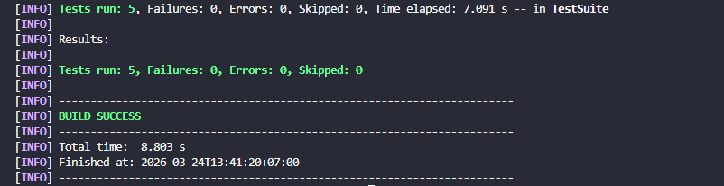
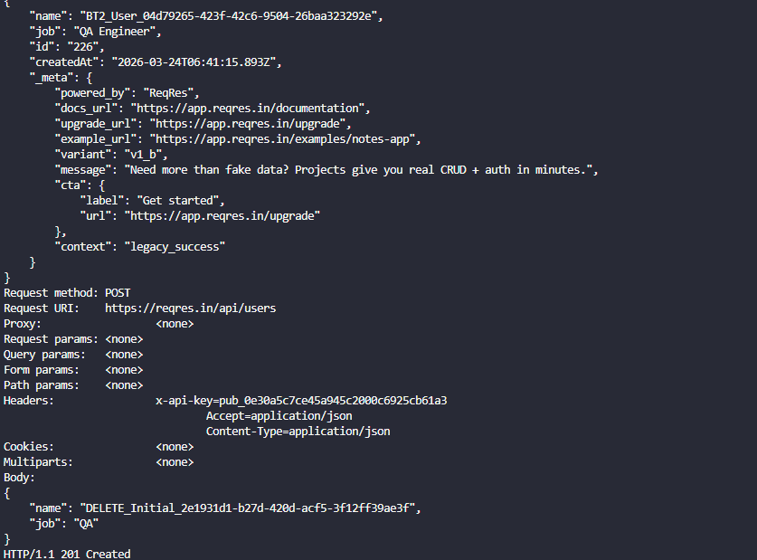
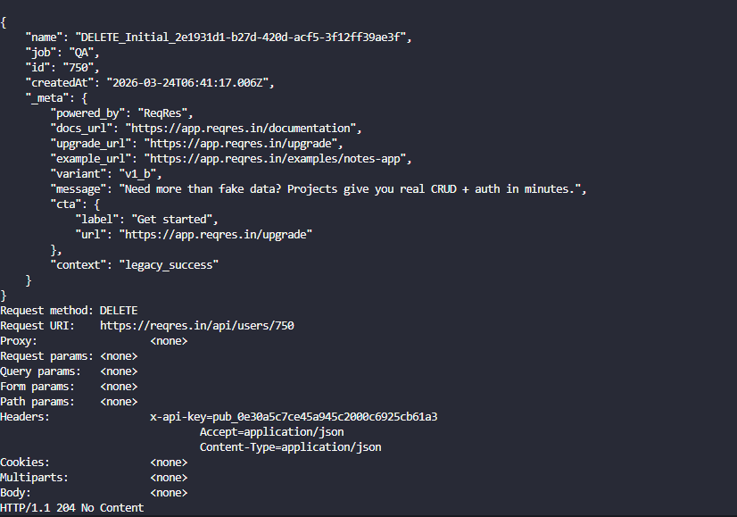
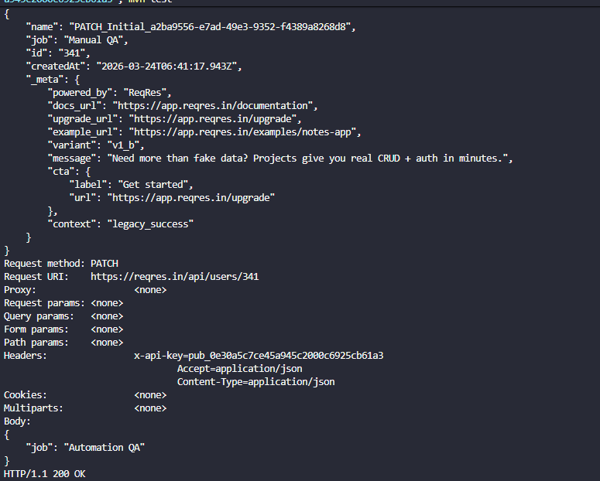
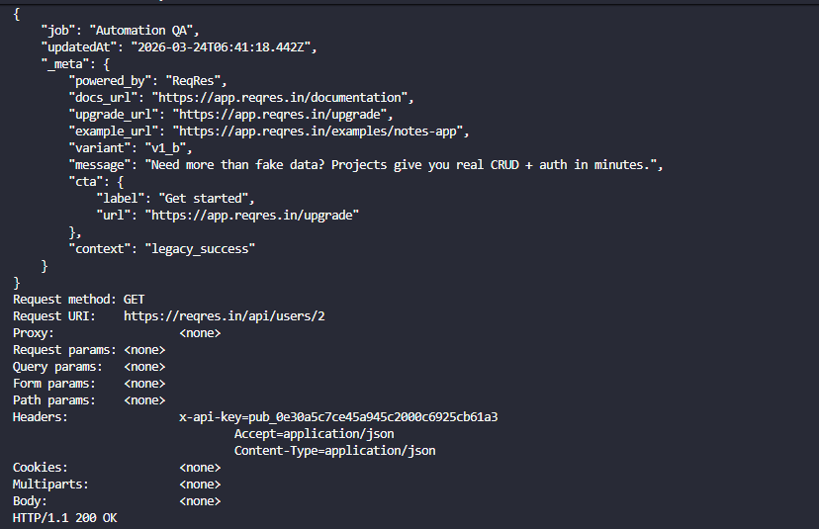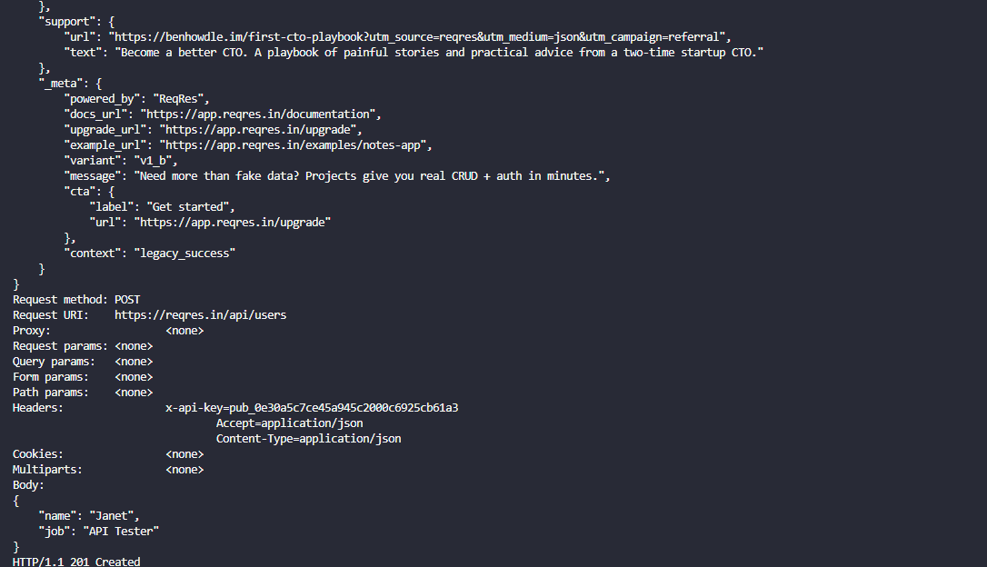
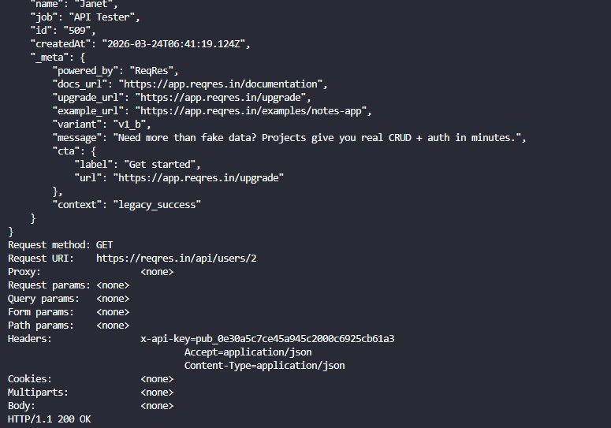
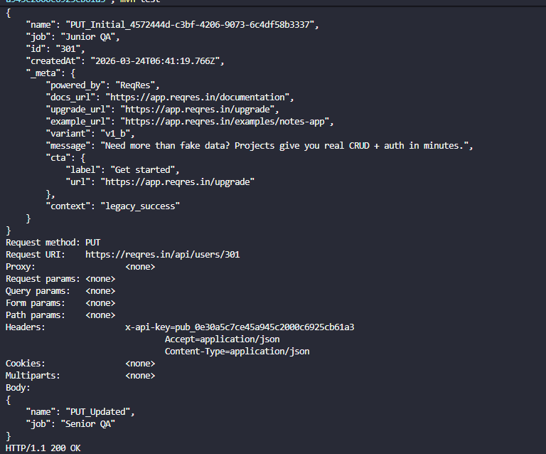
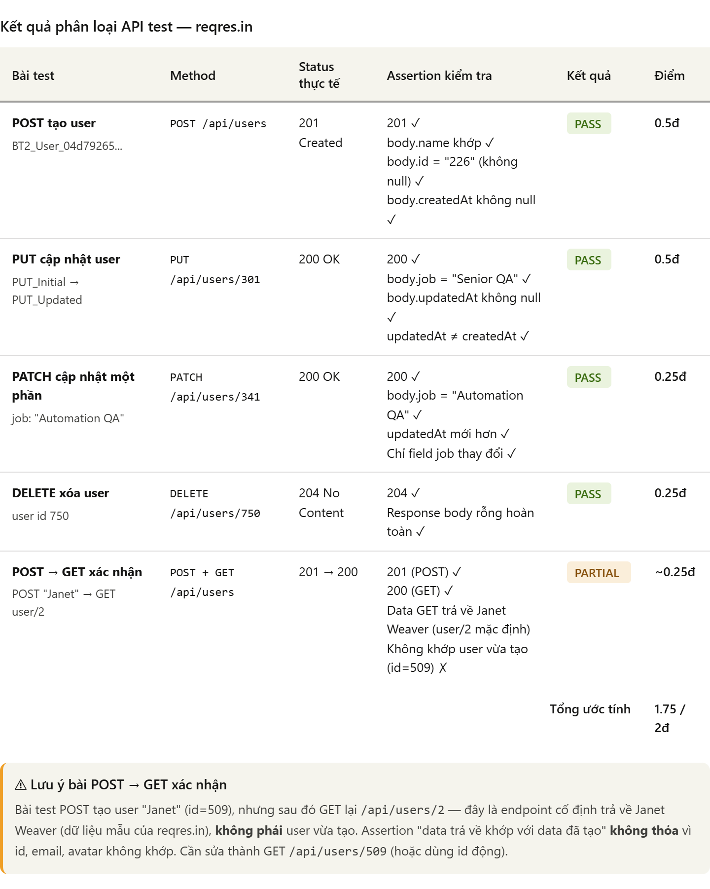
BT3
Tạo file schemas/user-list-schema.json kiểm tra response GET /api/users: phải có
page (integer), total_pages (integer), data (array), mỗi item trong data phải có id,
email, first_name, last_name, avatar
{
"$schema": "http://json-schema.org/draft-07/schema#",
"type": "object",
"required": ["page", "per_page", "total", "total_pages", "data", "support", "_meta"],
"properties": {
"page": { "type": "integer", "minimum": 1 },
"per_page": { "type": "integer", "minimum": 1 },
"total": { "type": "integer", "minimum": 1 },
"total_pages": { "type": "integer", "minimum": 1 },
"data": {
"type": "array",
"minItems": 1,
"items": {
"type": "object",
"required": ["id", "email", "first_name", "last_name", "avatar"],
"properties": {
"id": { "type": "integer", "minimum": 1 },
"email": { "type": "string", "format": "email" },
"first_name": { "type": "string", "minLength": 1 },
"last_name": { "type": "string", "minLength": 1 },
"avatar": { "type": "string", "format": "uri" }
},
"additionalProperties": false
}
},
"support": {
"type": "object",
"required": ["url", "text"],
"properties": {
"url": { "type": "string", "format": "uri" },
"text": { "type": "string", "minLength": 1 }
},
"additionalProperties": false
},
"_meta": {
"type": "object",
"required": ["powered_by", "docs_url", "upgrade_url", "example_url", "variant", "message", "cta", "context"],
"properties": {
"powered_by": { "type": "string", "minLength": 1 },
"docs_url": { "type": "string", "format": "uri" },
"upgrade_url": { "type": "string", "format": "uri" },
"example_url": { "type": "string", "format": "uri" },
"variant": { "type": "string", "minLength": 1 },
"message": { "type": "string", "minLength": 1 },
"cta": {
"type": "object",
"required": ["label", "url"],
"properties": {
"label": { "type": "string", "minLength": 1 },
"url": { "type": "string", "format": "uri" }
},
"additionalProperties": false
},
"context": { "type": "string", "minLength": 1 }
},
"additionalProperties": false
}
},
"additionalProperties": false
}

Tạo file schemas/user-schema.json kiểm tra response GET /api/users/2: cấu trúc
nested object data và support
{
"$schema": "http://json-schema.org/draft-07/schema#",
"type": "object",
"required": ["data", "support", "_meta"],
"properties": {
"data": {
"type": "object",
"required": ["id", "email", "first_name", "last_name", "avatar"],
"properties": {
"id": { "type": "integer", "minimum": 1 },
"email": { "type": "string", "format": "email" },
"first_name": { "type": "string", "minLength": 1 },
"last_name": { "type": "string", "minLength": 1 },
"avatar": { "type": "string", "format": "uri" }
},
"additionalProperties": false
},
"support": {
"type": "object",
"required": ["url", "text"],
"properties": {
"url": { "type": "string", "format": "uri" },
"text": { "type": "string", "minLength": 1 }
},
"additionalProperties": false
},
"_meta": {
"type": "object",
"required": ["powered_by", "docs_url", "upgrade_url", "example_url", "variant", "message", "cta", "context"],
"properties": {
"powered_by": { "type": "string", "minLength": 1 },
"docs_url": { "type": "string", "format": "uri" },
"upgrade_url": { "type": "string", "format": "uri" },
"example_url": { "type": "string", "format": "uri" },
"variant": { "type": "string", "minLength": 1 },
"message": { "type": "string", "minLength": 1 },
"cta": {
"type": "object",
"required": ["label", "url"],
"properties": {
"label": { "type": "string", "minLength": 1 },
"url": { "type": "string", "format": "uri" }
},
"additionalProperties": false
},
"context": { "type": "string", "minLength": 1 }
},
"additionalProperties": false
}
},
"additionalProperties": false
}

Tạo file schemas/create-user-schema.json kiểm tra response POST /api/users: phải
có name (string), job (string), id (string), createdAt (string)
{
"$schema": "http://json-schema.org/draft-07/schema#",
"type": "object",
"required": ["name", "job", "id", "createdAt", "_meta"],
"properties": {
"name": { "type": "string", "minLength": 1 },
"job": { "type": "string", "minLength": 1 },
"id": { "type": "string", "minLength": 1 },
"createdAt": { "type": "string", "format": "date-time" },
"_meta": {
"type": "object",
"required": ["powered_by", "docs_url", "upgrade_url", "example_url", "variant", "message", "cta", "context"],
"properties": {
"powered_by": { "type": "string", "minLength": 1 },
"docs_url": { "type": "string", "format": "uri" },
"upgrade_url": { "type": "string", "format": "uri" },
"example_url": { "type": "string", "format": "uri" },
"variant": { "type": "string", "minLength": 1 },
"message": { "type": "string", "minLength": 1 },
"cta": {
"type": "object",
"required": ["label", "url"],
"properties": {
"label": { "type": "string", "minLength": 1 },
"url": { "type": "string", "format": "uri" }
},
"additionalProperties": false
},
"context": { "type": "string", "minLength": 1 }
},
"additionalProperties": false
}
},
"additionalProperties": false
}

Viết test cho cả 3 schema, đặt additionalProperties: false trong schema → test sẽ
FAIL nếu backend thêm field mới không khai báo
package bt3;

import org.testng.Assert;
import org.testng.annotations.Test;

import java.util.HashMap;
import java.util.Map;

import static io.restassured.RestAssured.given;
import static io.restassured.module.jsv.JsonSchemaValidator.matchesJsonSchemaInClasspath;

public class JsonSchemaValidationTest extends ApiBaseTest {

@Test(description = "BT3.1 - Validate GET /api/users schema")
public void testUserListSchema() {
given()
.spec(requestSpec)
.queryParam("page", 1)
.when()
.get("/users")
.then()
.statusCode(200)
.body(matchesJsonSchemaInClasspath("schemas/user-list-schema.json"));
}

@Test(description = "BT3.2 - Validate GET /api/users/2 schema")
public void testSingleUserSchema() {
given()
.spec(requestSpec)
.when()
.get("/users/2")
.then()
.statusCode(200)
.body(matchesJsonSchemaInClasspath("schemas/user-schema.json"));
}

@Test(description = "BT3.3 - Validate POST /api/users schema")
public void testCreateUserSchema() {
Map<String, Object> request = new HashMap<>();
request.put("name", "Schema User");
request.put("job", "QA");

given()
.spec(requestSpec)
.body(request)
.when()
.post("/users")
.then()
.statusCode(201)
.body(matchesJsonSchemaInClasspath("schemas/create-user-schema.json"));
}

@Test(description = "BT3 Demo - Fail when schema misses a response field")
public void testSchemaShouldFailWhenFieldMissingInSchema() {
AssertionError error = Assert.expectThrows(AssertionError.class, () ->
given()
.spec(requestSpec)
.when()
.get("/users/2")
.then()
.statusCode(200)
.body(matchesJsonSchemaInClasspath("schemas/user-schema-demo-missing-avatar.json"))
);

Assert.assertTrue(
error.getMessage().contains("avatar") || error.getMessage().contains("additional") || error.getMessage().contains("schema"),
"Expected a clear schema mismatch message mentioning missing/extra field details"
);
}
}

Demo: Thêm field không có trong schema vào expected body → test phải FAIL với
thông báo rõ ràng về field bị thiếu/thừa
{
"$schema": "http://json-schema.org/draft-07/schema#",
"type": "object",
"required": ["data", "support", "_meta"],
"properties": {
"data": {
"type": "object",
"required": ["id", "email", "first_name", "last_name"],
"properties": {
"id": { "type": "integer", "minimum": 1 },
"email": { "type": "string", "format": "email" },
"first_name": { "type": "string", "minLength": 1 },
"last_name": { "type": "string", "minLength": 1 }
},
"additionalProperties": false
},
"support": {
"type": "object",
"required": ["url", "text"],
"properties": {
"url": { "type": "string", "format": "uri" },
"text": { "type": "string", "minLength": 1 }
},
"additionalProperties": false
},
"_meta": {
"type": "object"
}
},
"additionalProperties": false
}

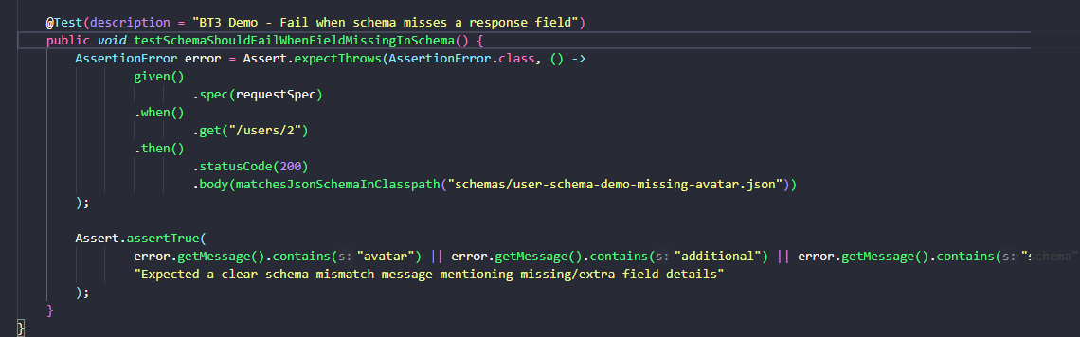
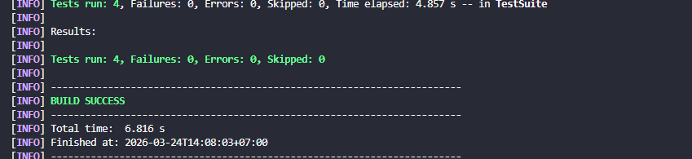
BT4
package bt4;

import org.testng.annotations.Test;

import java.util.HashMap;
import java.util.Map;

import static io.restassured.RestAssured.given;
import static org.hamcrest.Matchers.containsString;
import static org.hamcrest.Matchers.not;
import static org.hamcrest.Matchers.blankOrNullString;

public class AuthorizationTest extends ApiBaseTest {

@Test(description = "BT4.A1 - Login thanh cong")
public void testLoginSuccess() {
Map<String, String> body = new HashMap<>();
body.put("email", "eve.holt@reqres.in");
body.put("password", "cityslicka");

given()
.spec(requestSpec)
.body(body)
.when()
.post("/login")
.then()
.statusCode(200)
.body("token", not(blankOrNullString()));
}

@Test(description = "BT4.A2 - Login thieu password")
public void testLoginMissingPassword() {
Map<String, String> body = new HashMap<>();
body.put("email", "eve.holt@reqres.in");

given()
.spec(requestSpec)
.body(body)
.when()
.post("/login")
.then()
.statusCode(400)
.body("error", containsString("Missing password"));
}

@Test(description = "BT4.A3 - Login thieu email")
public void testLoginMissingEmail() {
Map<String, String> body = new HashMap<>();
body.put("password", "cityslicka");

given()
.spec(requestSpec)
.body(body)
.when()
.post("/login")
.then()
.statusCode(400)
.body("error", containsString("Missing email or username"));
}

@Test(description = "BT4.A4 - Register thanh cong")
public void testRegisterSuccess() {
Map<String, String> body = new HashMap<>();
body.put("email", "eve.holt@reqres.in");
body.put("password", "cityslicka");

given()
.spec(requestSpec)
.body(body)
.when()
.post("/register")
.then()
.statusCode(200)
.body("id", not(blankOrNullString()))
.body("token", not(blankOrNullString()));
}

@Test(description = "BT4.A5 - Register thieu password")
public void testRegisterMissingPassword() {
Map<String, String> body = new HashMap<>();
body.put("email", "sydney@fife");

given()
.spec(requestSpec)
.body(body)
.when()
.post("/register")
.then()
.statusCode(400)
.body("error", containsString("Missing password"));
}
}

package bt4;

import io.restassured.response.ValidatableResponse;
import org.testng.annotations.DataProvider;
import org.testng.annotations.Test;

import java.util.HashMap;
import java.util.Map;

import static io.restassured.RestAssured.given;
import static org.hamcrest.Matchers.containsString;

public class LoginDataDrivenTest extends ApiBaseTest {

@DataProvider(name = "loginScenarios")
public Object[][] loginScenarios() {
return new Object[][] {
{"eve.holt@reqres.in", "cityslicka", 200, null},
{"eve.holt@reqres.in", "", 400, "Missing password"},
{"", "cityslicka", 400, "Missing email or username"},
{"notexist@reqres.in", "wrongpass", 400, "user not found"},
{"invalid-email", "pass123", 400, "user not found"}
};
}

@Test(dataProvider = "loginScenarios", description = "BT4.B - Data-driven login error handling")
public void testLoginScenarios(String email, String password, int expectedStatus, String expectedError) {
Map<String, String> body = new HashMap<>();
if (email != null && !email.isEmpty()) {
body.put("email", email);
}
if (password != null && !password.isEmpty()) {
body.put("password", password);
}

ValidatableResponse response =
given()
.spec(requestSpec)
.body(body)
.when()
.post("/login")
.then()
.statusCode(expectedStatus);

if (expectedError != null) {
response.body("error", containsString(expectedError));
}
}
}

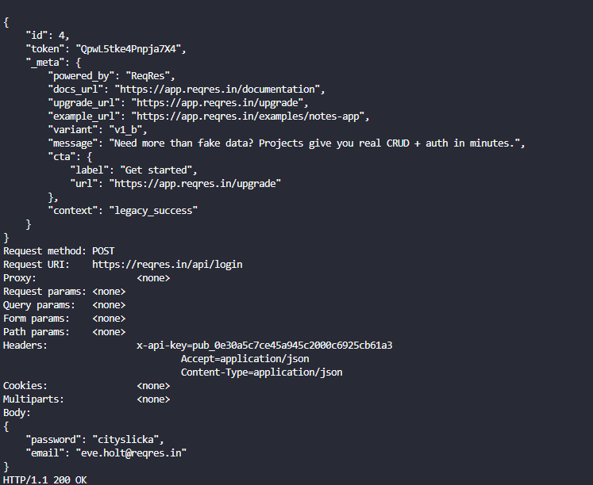
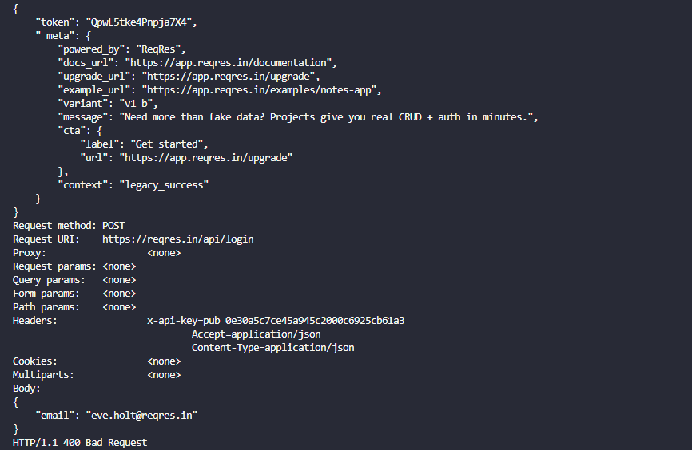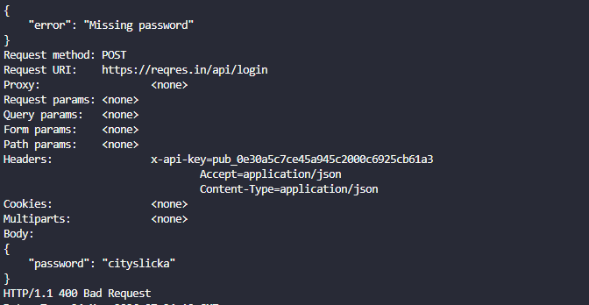
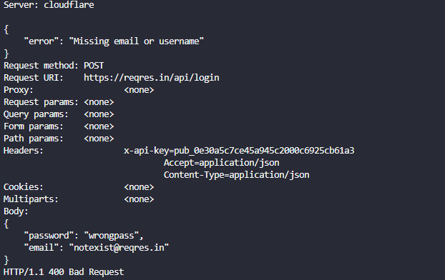
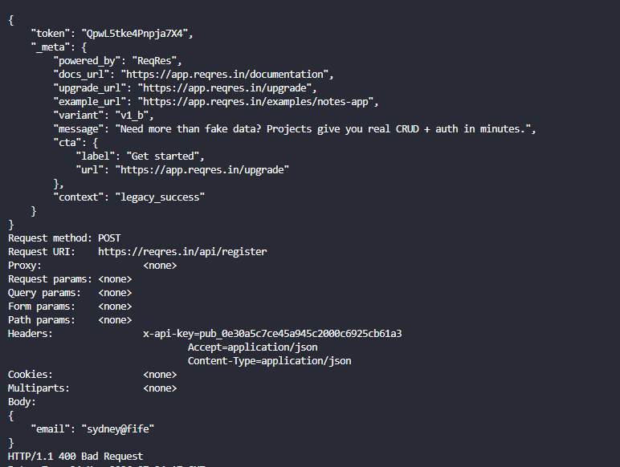
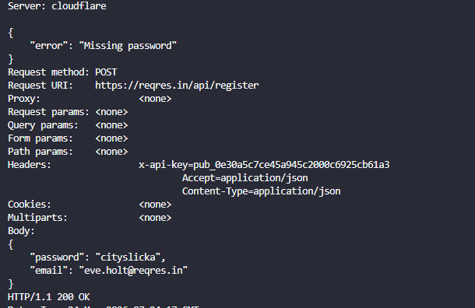
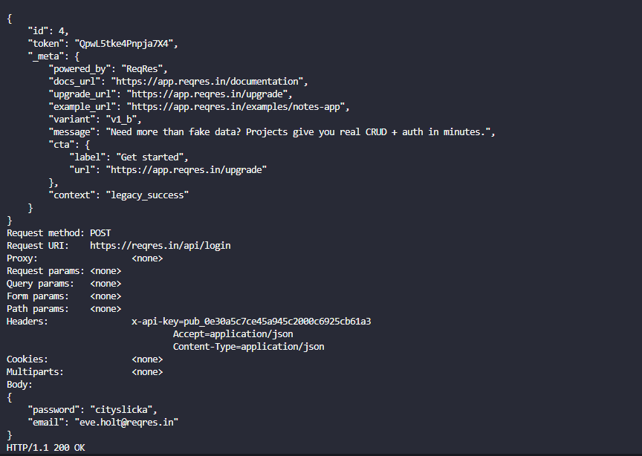
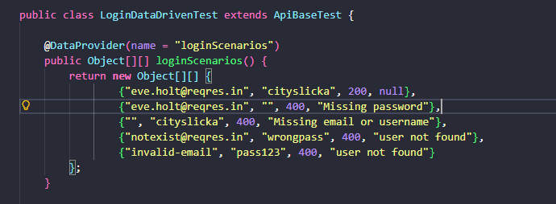
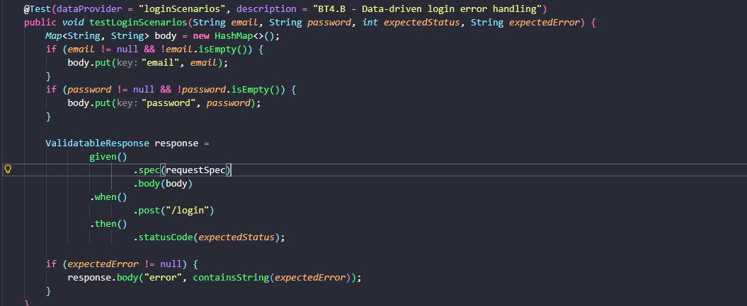
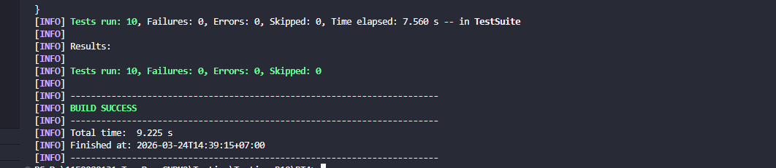

BT5
package bt5;

import io.qameta.allure.Step;
import io.restassured.response.Response;
import org.testng.Assert;
import org.testng.annotations.DataProvider;
import org.testng.annotations.Test;

import java.util.HashMap;
import java.util.Map;

import static io.restassured.RestAssured.given;
import static org.hamcrest.Matchers.equalTo;
import static org.hamcrest.Matchers.greaterThanOrEqualTo;
import static org.hamcrest.Matchers.not;
import static org.hamcrest.Matchers.blankOrNullString;

public class PerformanceSlaTest extends ApiBaseTest {

@DataProvider(name = "slaScenarios")
public Object[][] slaScenarios() {
return new Object[][] {
{"GET", "/users", 2000L, 200, "USERS_LIST"},
{"GET", "/users/2", 1500L, 200, "USER_BY_ID"},
{"POST", "/users", 3000L, 201, "CREATE_USER"},
{"POST", "/login", 2000L, 200, "LOGIN"},
{"DELETE", "/users/2", 1000L, 204, "DELETE_USER"}
};
}

@Test(dataProvider = "slaScenarios", description = "BT5 - Performance assertion va SLA monitoring")
public void testSlaForMainEndpoints(String method, String endpoint, long maxMs, int expectedStatus, String assertionType) {
Response response = callEndpoint(method, endpoint, maxMs);

long elapsedMs = response.time();
int statusCode = response.statusCode();

System.out.printf("[SLA] %s %s | actual=%dms | max=%dms | status=%d%n", method, endpoint, elapsedMs, maxMs, statusCode);

Assert.assertTrue(elapsedMs <= maxMs,
String.format("SLA violated for %s %s: actual=%dms, max=%dms", method, endpoint, elapsedMs, maxMs));
Assert.assertEquals(statusCode, expectedStatus, "Unexpected status code");

assertBusinessCondition(response, assertionType);
}

@Test(description = "BT5 - Monitoring GET /users 10 lan de tinh min/max/avg")
public void monitorUsersEndpointForTenRuns() {
final String method = "GET";
final String endpoint = "/users";
final long maxMs = 2000L;
final int runs = 10;

long min = Long.MAX_VALUE;
long max = Long.MIN_VALUE;
long sum = 0;

for (int i = 1; i <= runs; i++) {
Response response = callEndpoint(method, endpoint, maxMs);
long elapsed = response.time();

Assert.assertEquals(response.statusCode(), 200, "Unexpected status code in monitoring run");
response.then().body("data.size()", greaterThanOrEqualTo(1));

min = Math.min(min, elapsed);
max = Math.max(max, elapsed);
sum += elapsed;

System.out.printf("[MONITOR] run=%d | endpoint=%s | responseTime=%dms%n", i, endpoint, elapsed);
}

double avg = (double) sum / runs;
System.out.printf("[MONITOR SUMMARY] endpoint=%s | runs=%d | min=%dms | max=%dms | avg=%.2fms%n",
endpoint, runs, min, max, avg);
}

@Step("Goi {method} {endpoint} - SLA: {maxMs} ms")
private Response callEndpoint(String method, String endpoint, long maxMs) {
switch (method) {
case "GET":
return given()
.spec(requestSpec)
.when()
.get(endpoint)
.then()
.extract()
.response();
case "POST":
return given()
.spec(requestSpec)
.body(buildBodyByEndpoint(endpoint))
.when()
.post(endpoint)
.then()
.extract()
.response();
case "DELETE":
return given()
.spec(requestSpec)
.when()
.delete(endpoint)
.then()
.extract()
.response();
default:
throw new IllegalArgumentException("Unsupported method: " + method);
}
}

private Map<String, String> buildBodyByEndpoint(String endpoint) {
Map<String, String> body = new HashMap<>();
if ("/users".equals(endpoint)) {
body.put("name", "morpheus");
body.put("job", "leader");
} else if ("/login".equals(endpoint)) {
body.put("email", "eve.holt@reqres.in");
body.put("password", "cityslicka");
}
return body;
}

private void assertBusinessCondition(Response response, String assertionType) {
switch (assertionType) {
case "USERS_LIST":
response.then().body("data.size()", greaterThanOrEqualTo(1));
break;
case "USER_BY_ID":
response.then().body("data.id", equalTo(2));
break;
case "CREATE_USER":
response.then().body("id", not(blankOrNullString()));
break;
case "LOGIN":
response.then().body("token", not(blankOrNullString()));
break;
case "DELETE_USER":
// 204 No Content, no body assertion needed.
break;
default:
throw new IllegalArgumentException("Unsupported assertion type: " + assertionType);
}
}
}

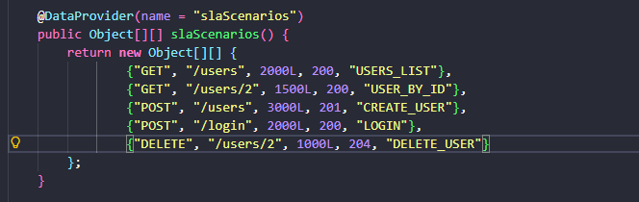
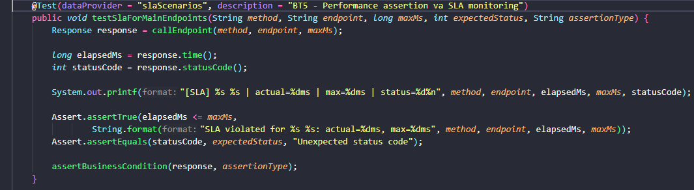
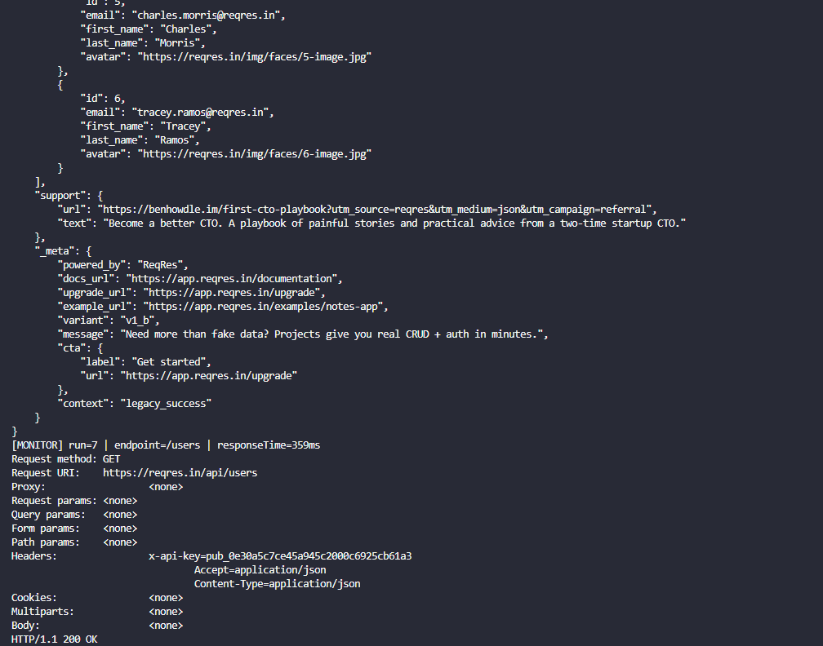
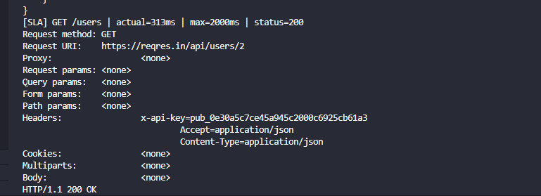
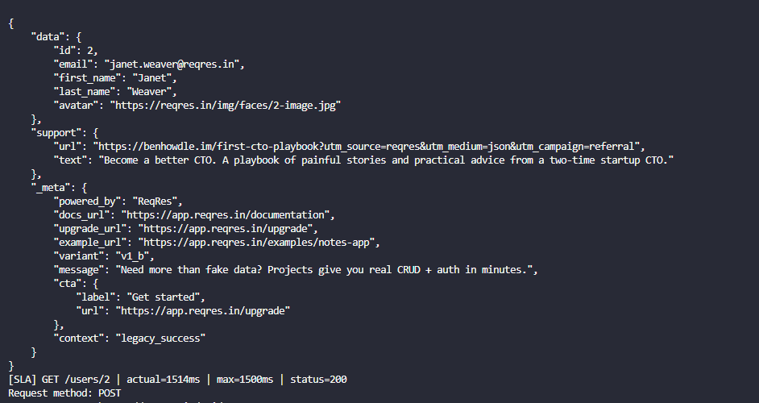
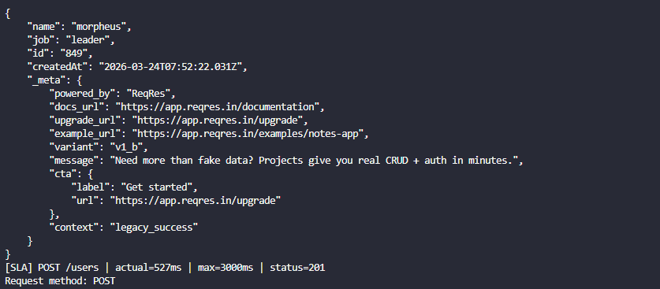
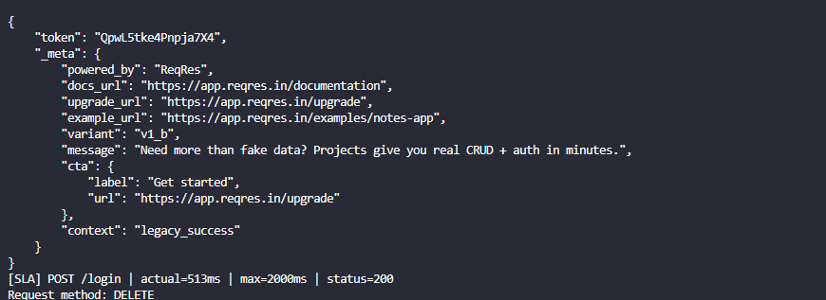
BT6
package bt6;

import io.restassured.response.Response;
import org.openqa.selenium.By;
import org.openqa.selenium.support.ui.ExpectedConditions;
import org.testng.Assert;
import org.testng.SkipException;
import org.testng.annotations.AfterMethod;
import org.testng.annotations.BeforeMethod;
import org.testng.annotations.Test;

import static io.restassured.RestAssured.given;

public class PartBFullIntegrationFlowTest extends ApiBaseTest {

private final UiBaseTest ui = new UiBaseTest();
private boolean isApiAlive;

@BeforeMethod
public void checkUsersApiHealth() {
// [API CHECK][Capture-B1] Verify ReqRes is alive via GET /users.
Response response = given()
.spec(requestSpec)
.when()
.get("/users")
.then()
.extract()
.response();

isApiAlive = response.statusCode() == 200;
// [API CHECK][Capture-B2] Console log that proves API health status and isApiAlive flag.
System.out.printf("[PartB][API] GET /users status=%d, isApiAlive=%s%n", response.statusCode(), isApiAlive);
}

@AfterMethod(alwaysRun = true)
public void cleanup() {
ui.closeBrowserIfOpened();
}

@Test(description = "Part B - API alive then UI login, add 2 products, verify cart")
public void fullApiUiIntegrationFlow() {
// API check: if ReqRes is not healthy, skip all UI actions.
// [PRECONDITION][Capture-B3] SkipException path for unavailable API.
if (!isApiAlive) {
throw new SkipException("ReqRes API is not alive. Skip UI flow.");
}

// [UI ACTION][Capture-B4] Login by real form input (no injection).
ui.setupBrowser();
ui.loginSauceDemoByForm("standard_user", "secret_sauce");

// [UI ACTION][Capture-B5] Add exactly 2 products.
ui.wait.until(ExpectedConditions.elementToBeClickable(By.id("add-to-cart-sauce-labs-backpack"))).click();
ui.wait.until(ExpectedConditions.elementToBeClickable(By.id("add-to-cart-sauce-labs-bike-light"))).click();

// [ASSERTION][Capture-B6] Cart badge must be 2.
String badgeText = ui.wait.until(ExpectedConditions.visibilityOfElementLocated(By.className("shopping_cart_badge"))).getText();
Assert.assertEquals(badgeText, "2", "Cart badge must be 2");

// [UI ACTION][Capture-B7] Open cart page.
ui.driver.findElement(By.className("shopping_cart_link")).click();

// [ASSERTION][Capture-B8] Cart must contain exactly 2 items.
int itemCount = ui.wait.until(ExpectedConditions.visibilityOfAllElementsLocatedBy(By.className("cart_item"))).size();
Assert.assertEquals(itemCount, 2, "Cart must contain exactly 2 products");
}
}

package bt6;

import io.restassured.response.Response;
import org.testng.Assert;
import org.testng.SkipException;
import org.testng.annotations.AfterMethod;
import org.testng.annotations.BeforeMethod;
import org.testng.annotations.Test;

import java.util.HashMap;
import java.util.Map;

import static io.restassured.RestAssured.given;

public class PartAApiPreconditionUiTest extends ApiBaseTest {

private final UiBaseTest ui = new UiBaseTest();
private boolean isLoginApiReady;
private String loginToken;

@BeforeMethod
public void loginApiPrecondition() {
// [API CHECK][Capture-1] POST /api/login to obtain token before UI.
Map<String, String> body = new HashMap<>();
body.put("email", "eve.holt@reqres.in");
body.put("password", "cityslicka");

Response response = given()
.spec(requestSpec)
.body(body)
.when()
.post("/login")
.then()
.extract()
.response();

isLoginApiReady = response.statusCode() == 200;
loginToken = response.jsonPath().getString("token");

// [API CHECK][Capture-2] Console log that proves status and token were received.
System.out.printf("[PartA][API] status=%d, token=%s%n", response.statusCode(), loginToken);
}

@AfterMethod(alwaysRun = true)
public void cleanup() {
ui.closeBrowserIfOpened();
}

@Test(description = "Part A - API precondition must pass before UI")
public void apiLoginPreconditionMustPass() {
// [PRECONDITION][Capture-3] SkipException path when API precondition fails.
if (!isLoginApiReady || loginToken == null || loginToken.isBlank()) {
throw new SkipException("API login precondition failed. Skip UI verification.");
}
}

@Test(dependsOnMethods = "apiLoginPreconditionMustPass", description = "Part A - UI verify URL and title after login")
public void uiVerifyAfterApiPrecondition() {
// [UI ACTION][Capture-4] Login by filling web form on SauceDemo (no API injection).
ui.setupBrowser();
ui.loginSauceDemoByForm("standard_user", "secret_sauce");

// [ASSERTION][Capture-5] URL must contain "inventory".
Assert.assertTrue(ui.driver.getCurrentUrl().contains("inventory"), "URL must contain 'inventory'");
// [ASSERTION][Capture-6] Page title must be "Swag Labs".
Assert.assertEquals(ui.driver.getTitle(), "Swag Labs", "Unexpected page title");
}
}

package bt6;

import io.github.bonigarcia.wdm.WebDriverManager;
import org.openqa.selenium.By;
import org.openqa.selenium.WebDriver;
import org.openqa.selenium.chrome.ChromeDriver;
import org.openqa.selenium.chrome.ChromeOptions;
import org.openqa.selenium.support.ui.ExpectedConditions;
import org.openqa.selenium.support.ui.WebDriverWait;

import java.time.Duration;

public class UiBaseTest {

protected WebDriver driver;
protected WebDriverWait wait;

protected void setupBrowser() {
WebDriverManager.chromedriver().setup();

ChromeOptions options = new ChromeOptions();
boolean headless = Boolean.parseBoolean(System.getProperty("ui.headless", "false"));
if (headless) {
options.addArguments("--headless=new");
}
options.addArguments("--window-size=1920,1080");
options.addArguments("--disable-gpu");
options.addArguments("--no-sandbox");
options.addArguments("--disable-dev-shm-usage");

driver = new ChromeDriver(options);
wait = new WebDriverWait(driver, Duration.ofSeconds(15));
}

protected void loginSauceDemoByForm(String username, String password) {
driver.get("https://www.saucedemo.com/");

wait.until(ExpectedConditions.visibilityOfElementLocated(By.id("user-name"))).sendKeys(username);
driver.findElement(By.id("password")).sendKeys(password);
driver.findElement(By.id("login-button")).click();
}

protected void closeBrowserIfOpened() {
if (driver != null) {
driver.quit();
driver = null;
}
}
}

